Don’t Move Firewood Post
Pack marshmallows, not firewood!
Moving firewood can transport forest insects and diseases.
Emerald ash borer has been confirmed in Vermont. Do you part to help and buy firewood where you burn it!
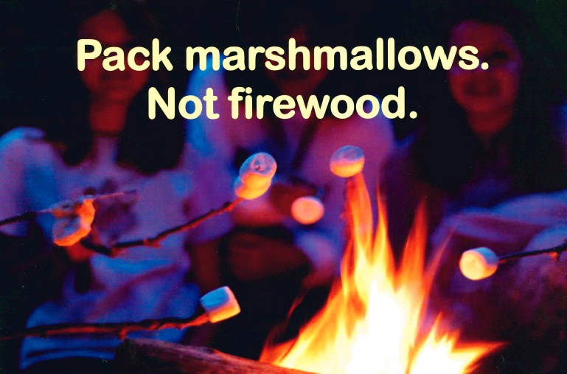
Learn more at VTinvasives.org!

Emerald Ash Borer in Vermont
Emerald ash borer (EAB), an invasive forest pest, has been confirmed in Vermont.
EAB is a major threat to our trees and forests. The emerald ash borer has feasted on over 100 million ash trees in the Midwest, where it was first discovered in 2002. Unless treated with insecticides, most infested trees die within 3 to 5 years. Experience in Michigan and other states has shown that once this pest is detected in an area, more detections follow quickly — and the ash trees die rapidly over a few short years. EAB was confirmed in Vermont and 2018 and there are currently confirmed infestations in five Vermont counties.
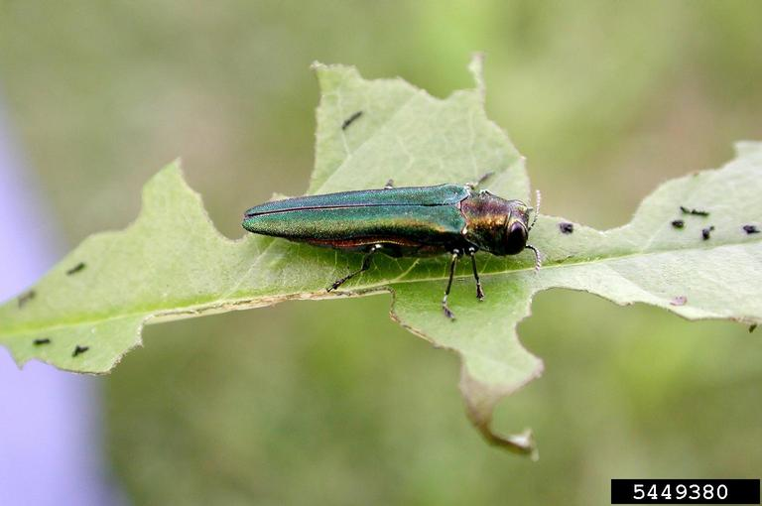
- Learn how to identify ash trees and emerald ash borer signs and symptoms. Visit VTinvasives.org for more information!
- Look at ash trees for signs and symptoms – if you see a suspicious trees submit photos on the ReportIT! button at VTinvasives.org
- Slow the spread: burn firewood as close to the source as possible and do not move it outside of infested areas.
Photo Credit: Debbie Miller, US Forest Service, Bugwood.org

